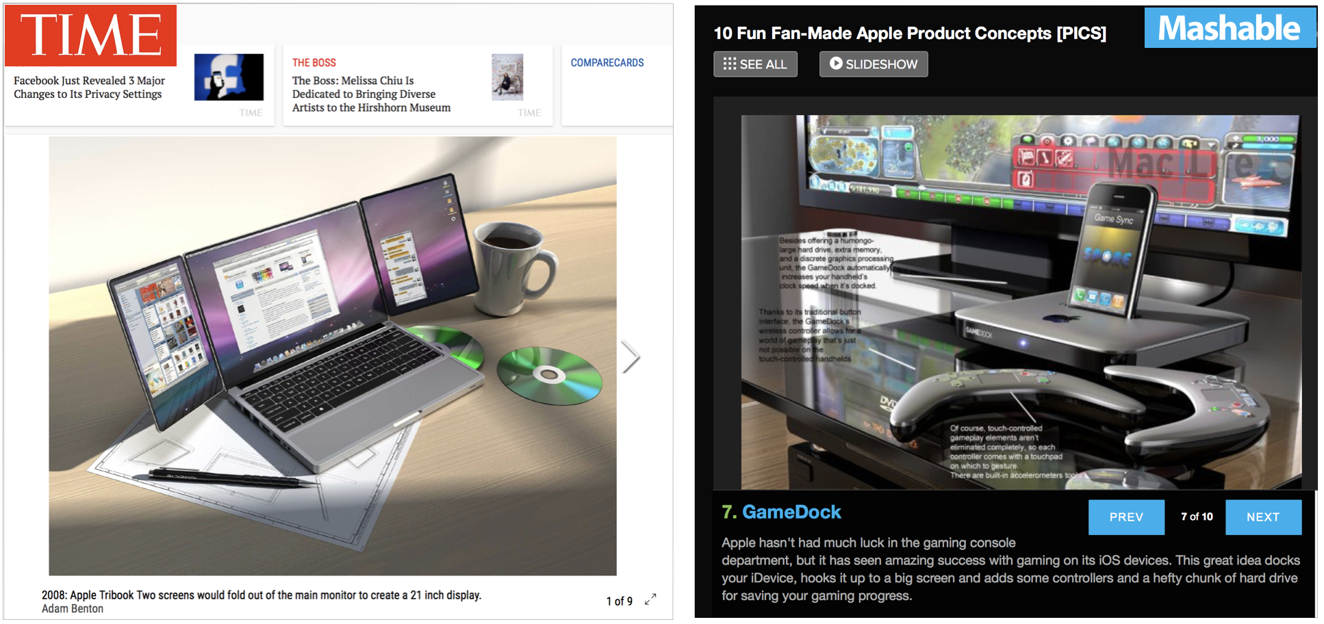
Figure 11. Two curated slideshows of different design fan fictions from the established media outlets TIME magazine (left) and Mashable (right).

