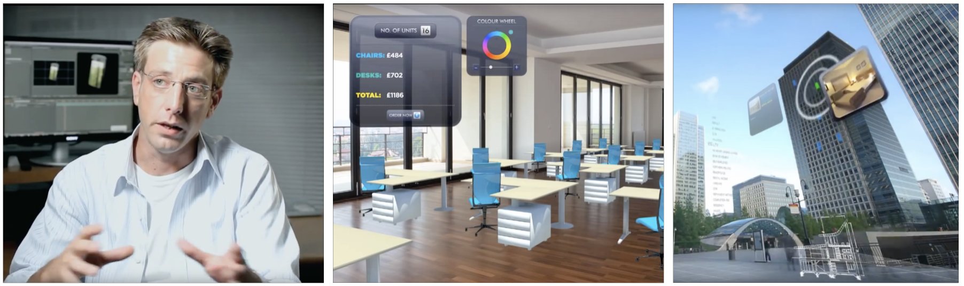
Figure 9. Stills from Hidden Creative’s concept video, discussing the future possibilities they see in various augmented reality platforms, and how they as an agency will approach the field.

