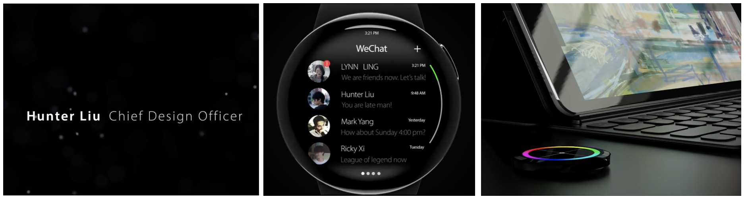
Figure 8. Stills from Liu’s Apple Watch X concept video, starting by mimicking the role of chief designer (left), then narrating various interface changes (middle) and new possible features for the watch (right).

