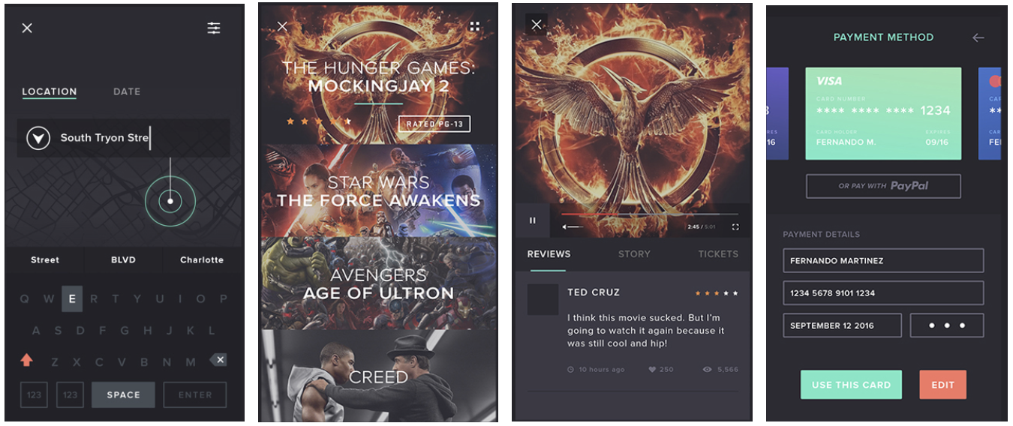
Figure 4. Stills from Martinez’s Cine-App video concept, from searching for a cinema to booking a ticket.

