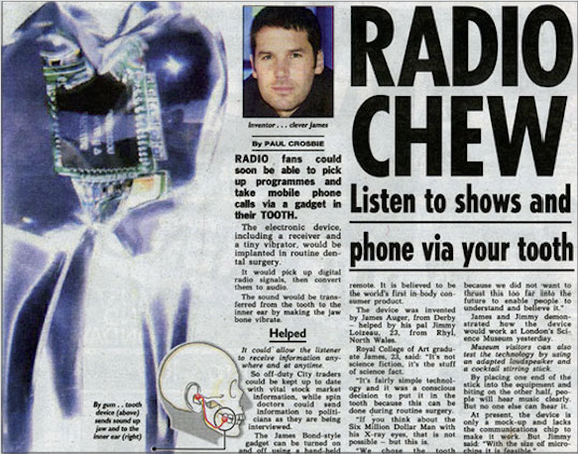
Figure 1. An example of a design fiction, used as critical design scenario by Auger (2013), portraying a diegetic prototype of an audio-connected tooth implant, which steered a debate in popular media about the scope of embodied technologies. From ‘The Sun’ newspaper (June 29th 2002).

